Thomas Pedraza
25 APR 2018
CSC 562
Assignment 6
sem_unlink() removes a specific semaphore. If the unlink call is absent from a program that uses semaphores, the mutex file with the given name will remain in the directory dev/shm. Figure 1 demonstrates the exclusion of sem_unlink().
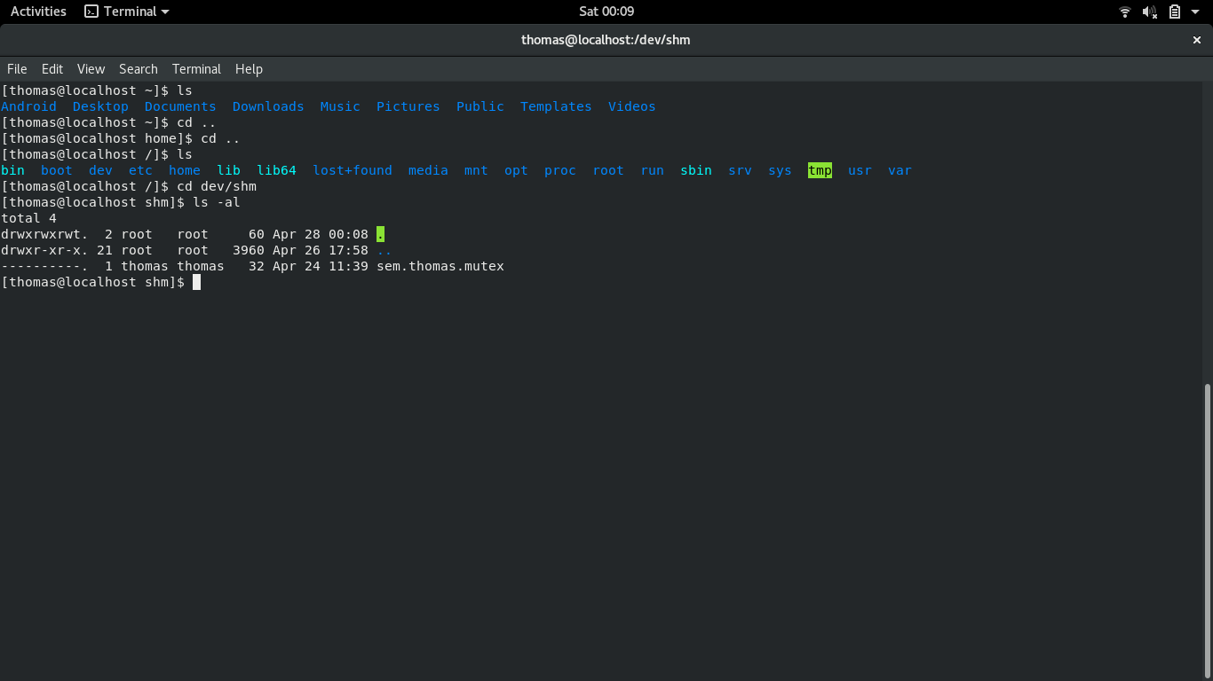
Figure 1: sem_unlink() excluded from program
Figure 2 shows 3 different parameters in prseq, all which count sequentially from 0 to maxnum using semaphores.
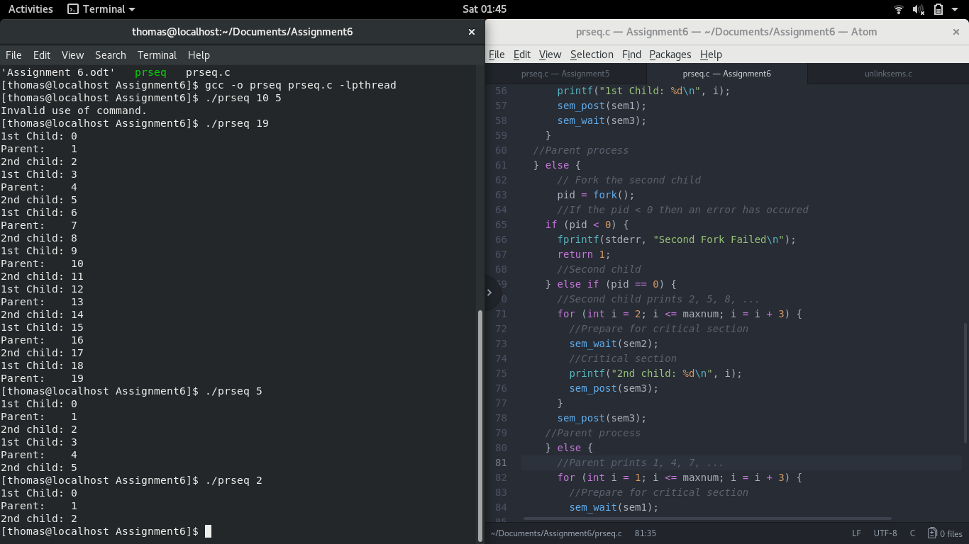
Figure 2: prseq parameters of 19, 5, and 2.

